NAME: ALVEENA NAZ
REG NO. FA25-BSE-010
OOP LAB 10

ACTIVITY 1:
import java.util.*;
public class JavaApplication64 {
public static void main(String[] args) {
ArrayList al = new ArrayList<>();
System.out.println("Initial Size of an array: " + al.size());
al.add("a");
al.add("b");
al.add("c");
al.add("d");
al.add(1,"a2");
System.out.println("Size of arrayList after an addition: " + al.size());
System.out.println("Content of arraylist: " + al);
al.remove(2);
System.out.println("Size of an array after removing: " + al.size());
System.out.println("Content of arraylist after removing: " + al);

}

}

OUTPUT:
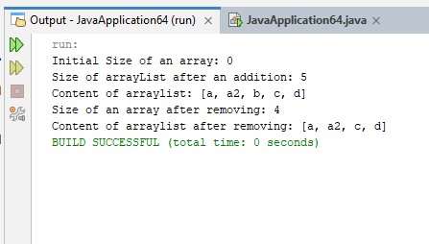

Activity 2:
import java.util.*;
public class JavaApplication64 {
public static void main(String[] args) {
Gen<Integer> g1;
g1 = new Gen<>(88);
g1.showType();
int a = g1.getT();
System.out.println("value is " + a);

Gen<String> g2;
g2 = new Gen<>("Generics Test");
g2.showType();
String b = g2.getT();
System.out.println("value is " + b);

}

}

public class Gen<T> {
T t;

Gen(T t){
this.t = t;
}

public T getT(){
return t;
}
public void showType(){
System.out.println("Type of T is " + t.getClass().getName());
}
}

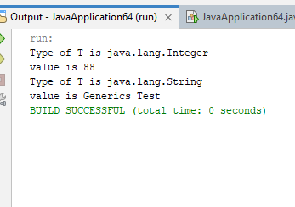

Activity 3:
import java.util.*;
public class JavaApplication64 {
public static void main(String[] args) {
Gen<Integer, String> g1;
g1 = new Gen<>(88,"Generics");
g1.showType();
int k = g1.getK();
System.out.println("K is " + k);
String v = g1.getV();
System.out.println("V is " + v);

}

}
public class Gen<K,V> {
K key;
V value;

Gen(K k, V v){
this.key = k;
this.value=v;
}

public K getK(){
return key;
}

public V getV(){
return value;
}
public void showType(){
System.out.println("Type of K is " + key.getClass().getName());
System.out.println("Type of V is " + value.getClass().getName());
}
}

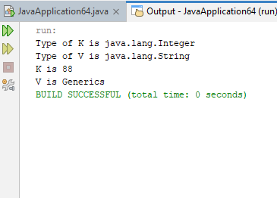

Graded task 1:
import java.util.*;
public class JavaApplication65 {
public static void main(String[] args) {
ArrayList<Contact> arr = new ArrayList<>();
Scanner input = new Scanner(System.in);

while(true){
System.out.println("1.Add Contact");
System.out.println("2.Display all contacts");
System.out.println("3.Search Term");
System.out.println("4.Exit");
System.out.println("Select from menu");
int choice = input.nextInt();
input.nextLine();
switch(choice)
{

case 1:
System.out.println("Enter first name");
String first = input.nextLine();
System.out.println("Enter last name");
String last = input.nextLine();
System.out.println("Enter Phone number");
String num = input.nextLine();
System.out.println("Enter email address");
String email = input.nextLine();
Contact c1 = new Contact(first,last,num,email);
arr.add(c1);
System.out.println("Contact added.");
break;
case 2:
for(Contact c: arr){
c.display();
}
break;
case 3:
System.out.println("Enter search term");
String term = input.nextLine();
for(Contact c: arr){
if((c.getFirstName().equalsIgnoreCase(term))||
(c.getLastName().equalsIgnoreCase(term))||
(c.getPhoneNum().equalsIgnoreCase(term))||
(c.getEmail().equalsIgnoreCase(term))){
System.out.println("Contact found");
c.display();
System.out.println("Do you want to delete it. Y/N");
String ch = input.next();
if(ch.equalsIgnoreCase("y")){
arr.remove(c);
System.out.println("Contact removed.");
}
break;
}

}
break;

case 4:
System.out.println("Logout.");
return;

}
}
}

}

public class Contact {
private String firstName;
private String lastName;
private String phoneNum;
private String email;
Contact(){}
Contact(String fn , String ln, String n, String email){
this.firstName=fn;
this.lastName=ln;
this.phoneNum=n;
this.email= email;
}
public void setFirstName(String fn){
this.firstName=fn;
}

public void setLastName(String ln){
this.lastName=ln;
}

public void setPhoneNum(String n){
this.phoneNum=n;
}

public void setEmail(String email){
this.email= email;
}

public String getFirstName(){
return firstName;

}

public String getLastName(){
return lastName;

}

public String getPhoneNum(){
return phoneNum;
}

public String getEmail(){
return email;
}
public void display(){
System.out.println("First Name: " + firstName);
System.out.println("last name: " + lastName);
System.out.println("Phone number: " + phoneNum);
System.out.println("Email: " + email);
}
}
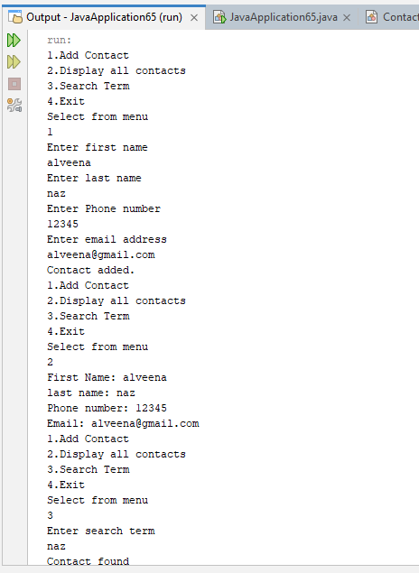
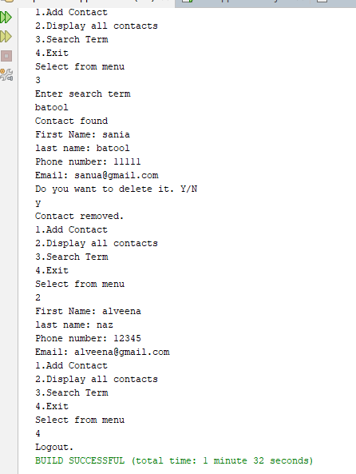

Graded Task 2:
import java.util.*;
public class Generic {
public static void main(String[] args) {
ArrayList<Integer> arr = new ArrayList<>();
arr.add(10);
arr.add(20);
arr.add(14);
MyMathClass<Integer> c1 = new MyMathClass<>();
System.out.println("Standard Deviation (Integer) "+c1.standardDeviation(arr));

}

}

import java.util.*;
public class MyMathClass<T extends Number>{
public double standardDeviation(ArrayList<T> list){
double sum =0.0;
for(T num : list){
sum+=num.doubleValue();
}

//mean
double mean = sum/list.size();

double varianceSum = 0.0;
for(T num : list){
varianceSum+=Math.pow(num.doubleValue() - mean , 2);
}

//standard deviation
double variance = varianceSum/list.size();
double standardDeviation = Math.sqrt(variance);

return standardDeviation;
}

}
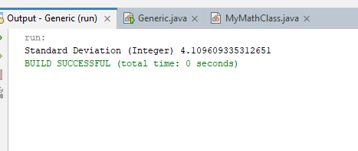

Graded Task 3:
import java.util.*;
public class Generic1 {
public static void main(String[] args) {
RandomBox<Integer> box = new RandomBox<>();
if( box.isEmpty()){
System.out.println("Box is empty");
}
box.addItem(30);
box.addItem(34);
System.out.println("Item draw is "+ box.drawItem());

RandomBox<String> box1 = new RandomBox<>();
if( box1.isEmpty()){
System.out.println("Box is empty");
}
box1.addItem("Ring");
box1.addItem("Neck");
System.out.println("Item draw is "+ box1.drawItem());
}

}

import java.util.*;
public class RandomBox<T>{
ArrayList<T> box;

RandomBox(){
box = new ArrayList<>();
}

public void addItem(T item){
box.add(item);
}
public boolean isEmpty(){
if(box.isEmpty())
return true;

return false;
}

public T drawItem(){
if(isEmpty()){
return null;
}

Random rand = new Random();
int index = rand.nextInt(box.size());

T randItem = box.get(index);
box.remove(index);

return randItem;
}
}

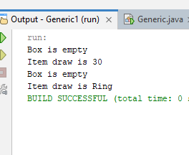

Graded Task 4:
import java.util.*;
public class JavaApplication68 {
public static void main(String[] args) {
Scanner input = new Scanner(System.in);
ArrayList<Double> score = new ArrayList<>();
System.out.println("Enter degree of difficulty (1.2-3.8)");
double degree = input.nextDouble();
if(degree<1.2 || degree>3.8){
System.out.println("Enter degree of difficulty between 1.2-3.8");
return;
}

for(int i=0;i<7;i++){
System.out.println("Enter score of judge " + (i+1));
double s = input.nextInt();
score.add(s);
}

double highest = Collections.max(score);
double lowest = Collections.min(score);

score.remove(highest);
score.remove(lowest);

double sum =0.0;
for(double sc: score){
sum+=sc;
}
double total = sum * degree * 0.6;
System.out.println("The Diver's Score is " + total);
}

}
